Misawa Child and Youth Programs Parent Handbook
2022

Table of Contents

Welcome 1
Mission Statement 1
Philosophy 1
Goals and CYP Professionals 2
Program Administration 3
Eligibility 3
Waiting List 4
Fees 5
Late Pick-up 5
Termination/Withdrawal/Sublet 5
Patron Satisfaction and Concern Procedures 6
Emergency Procedures 6
Drill Procedures 6
Shelter in Place 6
Weather/Natural Disasters 6
Emergency Closing 7
Medical Emergency 7
Active Shooter 7
Programs and Services 7
Yoiko Child Development Center 8
Cheli School Age Care 8
Family Child Care Homes 8
Youth and Teen Programs 9
Youth and Sports Fitness Programs 9
Instructional Classes 9
Supporting Children/Youth
and families with special needs 10
Hourly Care 10
Transportation 10
Field Trips 11
Personal Belongings 11
Dress Attire 11
Holiday Celebration and Birthdays 11
Transitions 12
Technology/Social Networking
in Youth Programs 12
Parent Involvement 13
Visit the CYP 13
Engage in your child’s Learning Process 13
Communicate with your CYP Professionals 13
Daily Notes and Verbal Updates 14
Parent Information boards and Newsletters 14
Resource Library 14
Parent Advisory Board 14
Parent Conferences 15
Behavioral Guidance 15
Positive Guidance Strategies 15
Positive Guidance Strategies: Youth 16
Child Safety 16
Inspections 16
Sign-In/Out Procedures 17
Visitors 17
Appropriate Touch 17
Child Abuse Prevention, Identification
and Reporting 18
Closed Circuit Television Systems 18
Accident/ Injuries 19
Reasonable Expectations for Behavior 19
Health 19
Concussion Protocols 20
Admission Requirements 20
Child Sick Policy 20
Medication 20
Immunizations 21
Control of Infectious Disease 21
Smoking/Alcohol/drugs Policy 21
Vehicles 22
Nutrition and Obesity Prevention 22
Meals and Snacks 22
Infant Feeding 23
Physical Activity 23
Screen Time 23
Incident/Accident Report 23
Key Personnel 24
Signs and Symptoms Chart 25
Accreditation 30
Helping Agencies 31
Welcome

Welcome to Misawa Air Base Child and Youth Programs (CYP). This handbook is provided to give you an overview of our programs, to introduce you to our philosophy and curriculum, and to familiarize you with the policies and procedures that govern our programs. Our goal is to create a quality environment that is safe, healthy, and nurturing. We strive to promote the physical, social, emotional and cognitive development of all children/youth. Choosing childcare and youth programming for your family is an important decision, which may be further complicated by military lifestyles. We know that military life comes with unique experiences and rewards of its own. While your children may face more than the usual challenges growing up, they also have the benefit of receiving high-quality early care and education from qualified professionals who can assist them in learning and in coping with these challenges. CYP provides quality programs and services to nurture and support children as they navigate life in a military family, including care for your children during nontraditional work hours. We are also dedicated to supporting the inclusion of children of all races, ethnicities, and abilities in CY programs. All programs are committed to partnering with parents to provide a stable foundation for early learning and school readiness. Working together, we can help build a secure and successful future for your children.

Child and Youth Program Mission

The mission of Air Force CYP is to assist Department of Defense (DoD) military and civilian personnel in balancing the competing demands of the accomplishment Of the DoD mission and family life through delivery of a system of quality, available and affordable programs and services for eligible children and youth birth through 18 years of age.

Philosophy

To provide high quality educational and recreational programs for children and youth. Teams of caring, knowledgeable professionals plan developmentally appropriate programs that are responsive to the unique needs, abilities, and interests of children and youth. CYP professionals are trained to foster a sense of independence, trust, and responsibility within the child/youth through understanding and respectful interactions. Programs are designed to support the ideas, cultures, and values of families and the staff are advocates for children/youth, families, and the CYP professionals within our programs.

Goals

Misawa CYP strives to promote optimum social, emotional, cognitive, and physical development of children and youth through support of the following goals:
- Foster positive identity and sense of emotional well-being
- Provide opportunities to enhance social skills.
- Encourage children to think, reason, question, and experiment.
- Promote language and literacy development.
- Build physical development and skills.
- Support sound health, safety, and nutritional practices
- Advance creative expression, representation, and appreciation for the arts
- Appreciate and respect cultural diversity.
- Develop initiative and decision-making skills.

CYP Professionals

Misawa CYP professionals are highly trained in child and youth development and experienced in planning developmentally-appropriate programs. Extensive training is provided prior to the staff working with children, and within the first 18 months of hire. Training opportunities are offered annually to ensure that CYP professionals maintain the necessary skills and competencies to meet the needs of children in their care. Ongoing training also supports continuous professional development and ensures that the latest developments in the field are implemented in the CYP.

Additionally, all CYP professionals undergo extensive background checks. In Family Child Care (FCC) Homes, providers and each family member 12 years and older residing in the home are required to complete appropriate criminal history checks prior to caring for children. At facility-based programs (e.g., Child Development Center, School Age Care program, Teen Center, Youth program), staff with background checks in progress may work at the CYP if preliminary investigations are favorable and they are in line of sight of another CYP professional with a completed background investigation. CYP professionals without completed background checks are clearly identified by the wearing of red smocks or shirts. While CYP staff wearing a blue smock or shirt, background checks have been satisfactorily completed.

Program Administration

CYP provide a work-force benefit to Active-Duty Military, DoD Civilians, Air National Guard, Air Force Reserve, and geographically disperse service members and their families by offering a myriad of child /youth development programs. Misawa CYPs include Yoiko Child Development Center (CDC), Family Child Care Homes (FCC), Cheli School-age Care (SAC) program, Lunny Youth Center, and Misawa Teen Center. Information related to program eligibility, wait list procedures, fees and discounts, and other administrative topics are summarized below.

Eligibility

Childcare eligibility is contingent on the status of the sponsor and to ensure that we are meeting our families’ needs, we follow the guidelines established by the DoD.

Your child/youth is eligible to use Misawa CYPs if you are:

- Active duty military;
- Combat-related wounded warrior;
- The surviving spouse or partner of a military member who died from a combat related incident;
- DoD civilian, paid from appropriated or non-appropriated funds;
- Air National Guard/Air Force reservist on active duty, deployment, or inactive duty while in training;
- A person acting in loco parentis for the dependent child of an eligible sponsor;
- DoD contractor;
- Active Duty Coast Guard, or
- A retiree, but only to register for recreational programs and activities. Full-time care may be available to children of retirees, but only if space is available after the care needs of personnel listed above have been met.

In addition, children are eligible if:

- They are the adopted, recognized biological children, stepchildren, or foster children of (and who are currently living with) an eligible sponsor.
- They are living with someone with a special power of attorney to act “in loco parentis” on behalf of an eligible sponsor; or
- They are the children of geographically separated or divorced families (of an eligible sponsor), and they live with the sponsor at least 25 percent of the time in the month they receive care.

Waiting List

Priorities are established in accordance with DoDI 6060.02, when a program has a waitlist, the following priorities are used:

- Priority 1: The order of precedence from highest to lowest within Priority 1 is as follows:

  - Priority 1A - Child Development Program Direct Care Staff
  - Priority 1B - Single/Dual Military Members and Military Members with a Full-Time Working Spouse
  - Priority 1C - Military Members with a Part-Time Working Spouse or those with a Spouse Seeking Employment
  - Priority 1D Military Members with a Spouse Enrolled Full-Time in a Post-Secondary Institution

- Priority 2: The second priority is given equally to active-duty Military Service members, DoD civilians paid from APF and NAF, surviving spouses of military members who died from combat related incident, where a non-working spouse is actively seeking employment. The status of actively seeking employment must be verified every 90 days.
- Priority 3: The third priority is given equally to active-duty Military Service members, DoD civilians paid from APF and NAF, surviving spouses of military members who died from combat related incident, where a non-working spouse is enrolled in a post-secondary institution. The status of post-secondary enrollment must be verified every 90 days.
- Space Available: After meeting the needs of parents in priorities 1, 2, and 3, programs shall support the need for care for other eligible patrons such as active-duty Military Service members with non-working spouses, DoD civilian employees paid from APF and NAF with non-working spouses, eligible employees of DoD Contractors, Federal employees from non-DoD agencies, and military retirees on a space available basis. In this category, programs may also authorize otherwise ineligible patron in accordance with reference (c). (In most cases, care for children in this category will not be eligible for subsidized care.) In accordance with AFI 34-144 Chapter 11 para 11.8.4.1, Space available patrons are notified at the time of enrollment that their space must be vacated if a higher priority patron requires childcare; parents must receive a 30 day written notice if their CDC/SAC space is needed. Families must notify the CDC if the spouse becomes unemployed. The spouse will have 30 days to obtain new employment or post-secondary enrollment. After which the CDC will provide a two week notice for a mandatory withdrawal if there are working parents on the waiting list. If more than 30 days is needed, a written request may be submitted to the CDC Director to be coordinated through the Flight Chief for leadership approval/disapproval.

Fees

Parent fees for care in military CDC, SAC programs, and subsidized FCC programs are based on Total Family Income (TFI). TFI must be verified during registration and at the time new rates go into effect with documentation from the Service Member/Civilian/Contractor and, if applicable, spouse’s most recent LES(s), W-2 forms, or detailed pay information. Students are required to provide proof of enrollment. Parents who choose not to show proof of income will be charged the highest fee category. Parents will be notified of fee changes at least 30 days in advance. Fees for SAC full-day weekly service during winter and summer breaks will be the same as the CDC basic weekly fees.

The Air Force Child and Youth Program Business Modernization System (AFSV-CYPBMS) Parent Portal. The Parent Portal allows you to securely manage your family’s profile to include program registration and payment information. Payments will be automatically generated in the online system; credit cards must be loaded in the system and payments will be deducted according to the payment schedule. Standardized Late payment fees will be $5.00 per day per family.

Late Pick Up

If you fail to pick up your child by the closing time of the CY program, every attempt will be made to reach you, your spouse and, as a last resort, a release designee listed on the child’s registration form. A late pick-up fee may be assessed after a 10-minute grace period at a rate of $2 per minute. Parents are allowed to use this grace period three times throughout the year. If violated, parents will lose the grace period and late fees will be applied at closing. If after 30 minutes no contact has been made, base security forces may be notified.

Termination/Withdrawal/Sublet Procedures

You are required to notify the CYP in writing a minimum of 2 weeks prior to the permanent withdrawal of your full-time child/youth. If a minimum of a 2-week advanced notice is not received, you may be responsible for ensuring the full 2-week payment is made to the CYP.

If you intend to temporarily withdraw your child/youth from CDC or SAC, you are encouraged to use the subletting program. Sublet boards are located at the CDC and SAC programs for you to sign-up. The Mission Support Group Commander is the approval authority for termination or suspension of enrollment.

Patron Satisfaction and Concern Procedures

We are committed to providing your child/youth with the best possible care. However, we know there may be times when you have suggestions and comments. Concerns or questions will be handled on a case by case basis and can be directed to the front desk or by contacting your Program Director. Information about the local process for handling command/program complaints is listed on the Local Installation Summary Sheet.

Emergency Procedures

Each CYP has a specific evacuation plan for drills as well as actual emergency evacuation plans. Evacuation plans are described Local Installation Summary Sheet. Fire drills, Shelter-in-Place, Active Shooter and other emergency exercises are conducted regularly and at various times of the day. The results of the exercises are documented and made available for parent to review. Details of all emergency procedures and evacuation plans are in an Evacuation Binder which is available in all CYP facilities. CYP will follow the installation inclement weather policy and procedures.

Drill Procedures

Fire drills are conducted once per month. Each building is required to evacuate in 2 minutes to be considered fully successful. Evacuation plans, reviewed and approved by the Fire Department, are available in key locations throughout the facilities.

Shelter in Place

Shelter in place drills are conducted twice per year.

Weather/ Natural Disasters

All children and staff shelter in place when notified severe weather is imminent. Children will not be released to parents or guardians until the “all clear” is sounded. If evacuation is necessary, children and staff will evacuate to a location deemed safe by the on-site Commander. Parents will be notified via phone or installation social media sites as the situation allows. Parents are also encouraged to monitor the Misawa AB website, the Child Development Center, Cheli School Age and Lunney Youth Center Facebook page and other local media outlets. Occupants will remain sheltered in place until notified by the emergency response authorities that the situation has been resolved or that an evacuation has been ordered.

Emergency Closing

It is our goal to support the mission by providing quality child care that meets the needs of the community. Parents will be notified via phone and/or by a variety of local media outlets should an emergency situation require unexpected closure or as ordered by the installation commander.

Medical Emergency

In the event of a medical emergency or accident resulting in an emergency 911 will be called. First Aid/ CPR will be administered as needed by trained personnel until EMS arrives. If a child is transported to a medical facility, a staff member will accompany the child to the medical facility with the child’s AF Form 1181 (emergency information/authorization for emergency medical care).

Active Shooter

In the event of an active shooter situation in the immediate area we will immediately turn off all lights, lock all doors and crouch below window lines until all clear is given. If an active shooter enters the facility we will make every effort to evacuate all children and staff to a safe location. Children and staff will shelter in place if unable to evacuate safely. As the situation allows, parents will be notified of the situation by telecom and/or local media outlets. Program management and staff will call parents to notify them of the situation and inform them where to re-unite with their child/ren. Children will not be released to parents/family members until authorized by the onsite commander.

Programs and Services

Yoiko Child Development Center

Yoiko Child Development Center provides quality child development programs for children ages six weeks to five years. The CDC is DoD certified and accredited by the National Association for the Education of Young Children (NAEYC). NAEYC, a membership organization that advocates on behalf of young children, sets and monitors standards for high-quality early childhood education programs and accredits programs that meet these standards. Yoiko CDC uses Early Learning Matters as the standard curriculum. This comprehensive, early childhood curriculum is based on a solid foundation of theory and research and incorporates basic fundamental beliefs about how children develop and learn; aligning with NAEYC Standards.

Yoiko CDC regular business hours are Monday through Friday from 0700-1700. Hourly Care is available upon request from 0900-1600. Extended Care is available on a case-by-case basis, please see the front desk for a Determination of Additional Care Form. The CDC is closed on weekends, federal holidays and when necessary due to inclement weather or natural disasters. Rates are not prorated for above mentioned closures. On PACAF Family Days, the CDC will be closed for business and credits will be given to families accordingly.

Cheli School Age Care

Cheli School-Age Care program provides quality “out of school” activities for children who have started kindergarten to 12 years of age. The programs are designed to enhance rather than duplicate the school day, are affiliated with The Boys & Girls Clubs of America (BGCA) and offer 4-H programs. Scheduled, developmentally appropriate activities in core program areas and technology are planned based on knowledge of youth development and needs and interests of the youth enrolled. Cheli SAC program is DoD certified and nationally accredited by the Council on Accreditation (COA). Cheli School Age Care is open from 0600 to 1800. The program offers Before School Care, After School Care, and Before and After School Care during the school year. When school is in session, the School Age staff walk the youth to and from school to the program. Times are based on the school’s hours of operation. Full day care is offered when school is not in session. Cheli SAC is closed on weekends, federal holidays and when necessary due to inclement weather or natural disasters. Rates are not prorated for above mentioned closures. On PACAF Family Days, SAC will be opened on a Reservation for care basis. Credits will be given to families not requiring care on PACAF Family Days.

Family Child Care Homes

Family Child Care Homes (FCC) offer quality care in a loving, learning home environment for children ages 4 weeks to 12 years. All homes are DoD certified. FCC providers are encouraged to obtain accreditation by the National Association for Family Child Care (NAFCC). As an additional quality assurance measure, FCC providers receive a minimum of one unannounced monitoring visit each month to assess providers’ relationships with children and families, appropriateness of the learning environment, planned activities, safety and health of the home, and other items. The goal of these visits is to provide programmatic support and ensure adherence to Air Force standards and policies.
All FCC Homes are required to use a developmentally-appropriate curriculum that meets the needs of the age groups of children in care. Your FCC provider can answer any questions and offer you specific information about the curriculum used in his/her program.

Youth and Teen Programs

Lunney Youth Center and Misawa Teen Center offer developmental and recreational programs for youth 9 through the age of 18. These programs are DoD certified and affiliated with BGCA and 4-H. Both organizations have long been recognized as offering programs and services to youth that can instill a sense of leadership and offer opportunities for educational and career exploration and development, expand health and life skills, support emerging technological skills, and incorporate arts, sports, fitness, and recreation. Youth thrive when presented with the resources for healthy development found in families, schools, and communities.
Youth sponsorship program facilitates the integration of dependent youth into their surroundings when moving to a new military installation due to the family's PCS. The sponsorship program is primarily directed to preteen and teenage youth and includes an outreach component to identify incoming youth, orientation to provide information about programs and activities on the installation and surrounding community, and a peer to peer component to connect current youth with incoming youth.

Youth Sports and Fitness Program

Our Youth Sports and Fitness (YSF) program plans, organizes, and conducts sports leagues, skills clinics, camps, fitness/health classes, special sporting events, and outdoor recreation activities for children and youth through the age of 18. Our Sports programs are affiliated with the National Alliance for Youth Sports and geared to support the developmental of fundamental motor skills needed for different sports and non-competitive physical activities. Stop by Lunney Youth Center for additional information and sports programs offered.

Instructional Classes

Our Youth Instructional Program, plans, organizes, and coordinates a wide range of instructional classes to offer youth a variety of recreational activities that they can explore and learn new skills and passions. Classes offered depend on the availability of instructors and the Misawa community needs. Children/youth from ages 18 months to 18 years, may participate in selected Instructional Classes. Stop by Lunney Youth center for additional information on Instructional Classes being offered.

Supporting children/youth and families with Special Needs

Parents are required to inform the Child and Youth program they are enrolling their children/youth of any special needs such as allergies, physical limitations, behavior problems etc. concerning the children/youth. Prior to enrolling in CYP the children/youth's developmental and/or medical requirements must be reviewed by the CYP Medical Advisor. CYP will work with the family to determine if an Inclusion Action Team (IAT) meeting is needed. The IAT include: the CYP Medical Advisor, the Medical Group Exceptional Family Member representative, the Flight Chief, the Flight Training and Curriculum Specialist, and Program Director. All professionals will collaborate with families and IAT to support all children/youth in CDC, FCC Homes, SAC, Youth, and Teen Programs with the process of designing and providing appropriate accommodations, and the IAT, which can help identify and access relevant resources, supports, and accommodations.

The purpose of the system of inclusion support is not to diagnose, exclude, or limit children within the CYP. The purpose of the IAT is to support CYP professionals in accommodating the needs of children and youth in the CYP and to assist the program in securing the necessary support and resources from varied agencies. As the family, you will be included throughout the process and encouraged to take an active role in collaborating with CYP professionals to support your children/youth in the program.

Hourly Care

Given the demands placed on military families, the need for occasional care can be particularly relevant. Because hourly care can be used in any situation and for any reason, it helps you when you need care other than full-time care. This includes intermittent needs for child care because of work schedules, doctor visits, illnesses, emergencies, or support to cope with daily or unique stressors. Hourly care is offered during normal operating hours when children are present. Spaces are based on space availability, and provided on a first come, first serve basis. Parents or guardians can make reservations up to 30 days in advance. Hourly care during regular and outside normal operating hours are offered in our FCC Homes.

Transportation

All vehicles used to transport your child/ youth to and from school and on field trips meet the school bus safety standards recommended by National Highway Traffic Safety Administration (NHTSA) and applicable State laws. The drivers are trained, licensed, and meet state, local, and installation requirements.

FCC providers who transport children/ youth in their private owned vehicles must provide documentation that their insurance provides proper coverage. The documentation will be maintained in the FCC provider's file.

Field Trips

Field trips are an important part of the CYP curriculum as they give children/youth first-hand experience of the world around them and provide variety away from the classroom. Field trips may include both walking trips and trips requiring transportation. Walking trips may take place daily and, in some cases, are part of the daily routine. While parents are not typically notified of “walking field trips” where children do not leave the installation, you will always be notified when your child is expected to leave the installation. You will be required to sign a field trip permission form upon enrollment and annually thereafter. This permission slip provides authorization for your child to participate in “walking field trips” and trips during which children do not leave the installation. Parents will be notified of any trips off the installation and will be required to sign a trip-specific permission form. Only preschool aged children and older will attend field trips requiring vehicle transportation.

Personal Belongings

Except on special occasions, items from home are not permitted as they may get misplaced or damaged. The CYP is not responsible for lost or damaged personal items, and you should avoid allowing your child/youth to bring toys or anything of value to the program. Young children are welcome to bring one soft comfort item to the CDC to help them feel safe and secure throughout the day, especially during naptime. Acceptable items will be described during parent orientation prior to enrollment. Pillows are prohibited for use by children younger than 3 years. Soft items such as bumpers and quilts may not be placed with an infant during sleep time. Each child will be provided a space to place his or her personal belongings.

Dress Attire

Your child/youth will participate in a variety of activities both indoors and out. Be sure to dress your child/youth in comfortable and weather appropriate clothes and shoes that are suitable for indoor and outdoor play, including sensory and sand activities, and for working with art materials. Closed-toe shoes are recommended. Also, it is strongly recommended that parents label all clothing that may be removed during the day (i.e., jackets, boots, sweaters, mittens) with your child’s name. For ages six and younger, please provide an extra set of seasonally appropriate clothing, including socks and underwear.

Holiday Celebrations and Birthdays

Misawa CYP respects families from all cultural backgrounds and strives to provide inclusive programming. You are encouraged to share your holiday traditions with the CYP professionals, so these events may be incorporated in the curriculum or daily activities. Military children have the opportunity for exposure to diverse cultures that provide them an enriched learning potential. CYP provides an outlet for you and your child/youth to share your family’s cultural traditions or observances with other children enrolled in the CYP.

Birthdays are unique events and opportunities to acknowledge and reinforce each child’s /youth’s personal identity. Monthly the program will help to celebrate your child’s/youth’s birthday at the CYP, please talk to the classroom teacher or program staff for more details.

Transitions

We recognize the importance of new beginnings – or transitions – in a child/youth development and what it means for the family. Children/youth need differ at various times during transition. Our attention, understanding, and ongoing communication with children/youth as well as parents can ease concerns during this time and facilitate children/youth adjustments to an unfamiliar environment.

The first transition families experience is from the home or other care program to Misawa CYP. During this time, you will receive information about the program as well a tour of the program. Parents are encouraged to share information about your child/youth’s preferences and schedule with CYP professionals, so care can be individualized. Families play a big part in ensuring a smooth and successful transition. Talk with your child/youth at home about the new program and teachers and discuss familiar features of the program (i.e., favorite toys, similar materials). A family member’s positive attitude, support, and assurances will make a significant difference in a smooth transition. Feel free to talk to CYP employees at any time for guidance or to address any concerns.

Children enrolled in the CDC periodically transition from one classroom to another. Factors considered during the transition decision-making process include classroom availability, child’s age, developmental readiness, class compatibility, class composition, and the child’s overall characteristics and needs. Classroom placement and transition decisions are individualized, since no one-size-fits-all approach is expected to ensure a successful transition for all children and families. Lead teachers and the Training and Curriculum Specialist carefully monitor each child’s growth and communicate with families on a regular basis.

During the transition, your child will be observed carefully to ensure he or she feels comfortable and confident in the new classroom environment. Misawa CYP will work with you to develop a transition plan that will best serve your child and your family. While parental input will be carefully considered, the CYP staff ultimately make the final decision about the placement and timing of a child’s transition.

Technology/Social Networking in Youth Programs

We encourage youth to engage in appropriate social networking activities such as staying in communication with deployed or duty–separated parents, connecting with friends that have PCS’d, and connecting with future CY programs (Youth Sponsorship). Computers are available in all facilities to afford youth an opportunity to explore interests in technology.

Parental control software is available at the CYP to prevent youth from accessing inappropriate sites. Parents may be asked to sign “Texting/Email Permission Slips” so that the CYP can send updates to teens about the latest activities scheduled at the Youth program. CYP professionals will not engage in one-on-one relationships with any youth, including e-mailing, texting, becoming Facebook friends or offering rides to youth in personal vehicles.

Parent Involvement

As a parent, your involvement and support are integral to your child’s/youth’s success. A strong partnership between parents and CYP professionals is of utmost importance in supporting your children’s healthy growth and development.

Visit the CYP

You will be provided numerous opportunities to observe your child/youth and participate in CYP. You are welcome to visit your child/youth at any time, unannounced, and join in the daily activities. CYP has an open-door policy and always welcomes visitors, input, and questions from parents. Feel free to contact the CYP professionals or the Program Directors at any time to ask questions or discuss concerns. CYP also encourages and appreciates parent volunteers.

Engage in your child’s learning process

We encourage you to get involved in your child’s learning and development at the CYP. Talk to your child/youth about what he or she is experiencing at the program, the activities he or she enjoys, and extend this learning beyond the program to your home.

Communicate with your CYP Professionals

You are encouraged to talk to your CYP professionals daily. Those who care for your child/youth each day can provide a wealth of observational information. Likewise, you as parents have valuable information to share with CYP professionals about your child/youth’s health, developmental progress, family environment, and much more that can assist them in supporting your child/youth appropriately. Several methods of communication are in place to encourage ongoing dialogue between CYP professionals and parents.

Daily Notes and Verbal Updates

You can expect regular, verbal and/or written communication with your CYP professional. If your child is under three years old, you will receive verbal and written information on your child’s sleeping and eating habits as well as other helpful information on your child’s day. If your child is three years old and older, you will receive verbal information about your child during pick-up.

Parent Information boards and Newsletters

Parent information boards with information relevant to families are posted throughout CYP facilities and FCC homes. Parent newsletters and Facebook pages are also provided to communicate information about extraordinary events and parent education classes.

Resource Library

Each CYP maintains a reference library of resource material for parents that cover a wide range of child and youth topics. In addition, each CYP has a location dedicated as a parent resource area, which contains brochures for various parent support resources.

Parent Advisory Board

To support the continued well-being of all children/youth in the programs and become more formally involved in the CYP, you are encouraged to participate in the Parent Advisory Board (PAB). Members of the PAB provide recommendations for improving services, help plan unique events, and discuss other opportunities for parent participation. The PAB is composed of parents of children and youth enrolled in each type of CYP, base personnel, and CYP professionals. We value your ideas and view the PAB as an opportunity to continue to improve the programs and services provided.

Parent Conferences

Parent conferences are held throughout the year based on the age of your child/youth and provide a venue for sharing information and discussing your child/youth’s developmental progress. These conferences provide an opportunity for you to receive feedback as well as offer input about your child/youth. At a minimum, you will be offered a parent conference at the following intervals:

- CDC: Parent conferences are offered once a year, and as needed.
- FCC Homes: Parent conferences are offered once a year.
- SAC, Youth, and Teen Programs: Parent conferences are offered as needed.

Behavioral Guidance

CYP professionals are better able to guide children/youth’s behavior when they have a solid understanding of how children/youth develop and learn. Self-regulation, planning and problem solving, and managing feelings are skills that children/youth develop and learn over time. Our CYP professionals promote positive guidance strategies to help them build upon these skills. Through modeling a behavior or using appropriate language to scaffold their learning, children/youth learn to manage their feelings and behaviors.

Positive Guidance Strategies

While each program uses specific guidance techniques for the age group(s) served, there are appropriate positive guidance techniques that apply to all children. Some of the strategies our professionals use to promote positive behaviors include fostering trusting relationships; responding to the individual needs of children with respect, acceptance and appreciation; establishing and maintaining a consistent daily schedule; allowing enough time for children to run and play outdoors; anticipating children/youth’s physical needs; being specific when speaking with children; and acknowledging children’s positive behavior. Children are more responsive to corrective guidance when they are feeling safe and secure in the relationship. Other positive guidance techniques that apply to all children regardless of age include modifying environments to accommodate the needs of individuals and groups of children; promoting positive relationships between children; setting limits by discussing what is allowed and not allowed; and eliminating or lessening waiting times for children to participate in activities.

Positive Guidance Strategies: Youth

Additional positive guidance techniques relevant to youth include the following:

- Using appropriate positive reinforcement techniques to encourage positive social interactions, promote conflict resolution, and develop self-control, self-motivation, and self-esteem.
- Encouraging children to resolve their own conflicts and assisting if needed to discuss the issues and work out solutions.
- Modeling positive adult interactions.
- Respecting participants’ rights not to be touched in ways that make them feel uncomfortable and respecting that touch is initiated by the child and not CYP professionals.
- Not allowing “horseplay,” rough, or physical play during program, sports, or specialized activities.

Child Safety

The safety of children/youth is our number one priority. Our programs have numerous processes in place to ensure your child is well protected.

Inspections

CY programs undergo rigorous daily, monthly, and annual inspections to include:

- Daily inspections of the facilities and grounds conducted by CYP professionals.
- Monthly unannounced fire inspections/fire drills and health/sanitation inspections conducted by fire/safety and health/sanitation personnel at center-based programs.
- Four annual inspections:
  - One annual unannounced comprehensive fire and safety inspection conducted by local, qualified fire and safety personnel.
  - One annual unannounced comprehensive health and sanitation inspection conducted by local health/sanitation personnel.
  - One local annual unannounced Multidisciplinary Team Inspection focusing on all aspects of program operation, including administrative procedures; facility, health, and safety procedures; and programming in CY Programs.
  - One Higher Headquarters Inspection. An annual Higher Headquarters inspection of all CYP facilities focusing on all aspects of program operation (e.g., administrative procedures; facility, health, and safety procedures; and programming).

Sign-In/Out Procedures

Children attending the CDC, FCC, or SAC program must be signed in and out of the program daily. When picking up your child/youth, be prepared to show your picture ID. When dropping off or picking up your child/youth, you must shut off and secure your vehicle in the parking lot. Children should never be left unattended in the parking lot.

Your child/youth will not be permitted to leave with anyone other than you unless written authorization has been provided in advance. The authorized person must present a valid picture ID before your child/youth will be released. Additionally, your child will not be permitted to leave with anyone younger than what is dictated in your parent agreement.

Your child/youth will not be released to anyone who is suspected to be under the influence of alcohol or drugs. If we have reason to believe you or your authorized pick up is under the influence or acts in a manner that may endanger the child/youth’s safety, Security Forces will be called for assistance.
CYP will not be involved in custody disputes. The parent who has legal custody of the child/youth must provide a copy of the court order should questions arise about the dependent custody. Parents will have access to their children/youth, including removing the child/youth from care. Parents will be denied access only if a court order, specifying that legally they may not have access to their child/youth.

Visitors

Visitors are required to sign the visitor’s log located at the front desk of the CYP facility or FCC Home. Visitors in facilities will be issued a visitor’s badge and escorted by a CYP professional. When a visitor is in the FCC home, providers will remain with the children in their care at all times, while being fully aware of the visitor’s location and actions. FCC providers will remain with the visitor for the duration of the visit. Parents attending events with their children are not considered visitors and therefore are not required to wear visitor badges or sign in.

Appropriate Touch

CYP professionals are trained to respect the personal privacy and space of others and use appropriate touching with all children and youth. Appropriate touch is gentle and positive and is natural and appropriate within the context of normal, acceptable adult/child interactions for each child’s age. For example, appropriate touch with young children may include cuddling, hugging, handholding, stroking, patting backs, and assisting in physical activities. While sitting on laps is appropriate for young children, it is not allowed for school-age children and youth. For older children, side-by-side contact is more appropriate.

Inappropriate touching is not allowed in CYP settings by any individuals. Examples of inappropriate touching include:

- Squeezing of the face or any areas of the body
- Pinching, hitting or punching, slapping, shaking or arm-twisting
- Tickling
- Restricting or physically restraining of the child’s movement by any means or in any way, except in limited, supervised circumstances when a child may harm self or others due to special needs.

- Physically restraining a child
- Any form of physical punishment
- Violating laws against adult/child physical/sexual contact
- Forcing of hugs, kisses or other touches on the child.

Child Abuse Prevention, Identification and Reporting

CYP professionals are required by law to report any suspected/alleged abuse/neglect directly to the Family Advocacy Office (FAO). The FAO initiates an investigation on any allegation once it has been determined it meets the criteria for a child abuse investigation. The FAO will then notify other required authorities as necessary. If you suspect child abuse or neglect, you should report it immediately to the proper authorities. Your local CYP Director can assist you in reporting your suspicion to Family Advocacy Office (FAO).
Parents may also report alleged child abuse and neglect directly to the DOD child abuse and safety hotline, US and in US Territories -1-877-790-1197 or Overseas-571-372-5348. Installation Family Advocacy Program 226-2123, Local Child Protective Services 226-2702. These hotline numbers are posted in all CYP facilities on parent information boards.

Closed Circuit Television Systems

The CYP facilities are equipped with closed circuit television systems (CCTV). These systems can serve as a significant child abuse deterrent and prevention mechanism for individuals working in the CYP. Further, CCTV systems also provide you with opportunities to observe your child/youth adjusting to child care without interrupting or distracting from your child/youth’s daily routine and activities. CCTV monitors are always available for parents to watch their children in real-time. However, parents are not allowed access to CCTV video recordings without obtaining authorization from the appropriate command authority via the CYP Director.
Accidents/ Injuries

We make every attempt to keep your child/youth safe and free from harm. Minor injuries will be treated with appropriate first aid procedures. If your child/youth is injured while participating in our program, we will provide immediate care for your child, contact you and emergency services if needed, and provide you with an accident/incident report for your signature. It is important to keep your child/youth’s emergency contact information current so you can be reached as soon as possible in the event of an accident or injury. All CYP Professionals are certified in CPR and Standard First Aid. If the injury involves another child, CYP staff are required to maintain confidentiality of the identity of the other child/youth.

Reasonable Expectations for Behavior

Although great care is taken to safeguard children/youth, hitting, scratching, throwing objects, falling, and biting occur in group care – even with small group sizes and good supervision. Learning acceptable behavior is part of growing up. If your child/youth is scratched or hit, your child/youth will be comforted and the injury treated if necessary. The other child/youth, depending on the age, will talk with the CYP professional about not hurting friends and will be redirected to acceptable behavior. CYP professionals will write an Accident/Injury report for each set of parents and explain the situation to each parent.

CYP professionals are trained to work with children/youth who display behavioral issues. However, if a child/youth continues to display inappropriate behavior, a conference will be requested with the parents. In extreme cases, when the safety of other children/youth becomes a concern, or a child begins to require one-on-one constant supervision, assistance from the Inclusion Action Team (IAT) may be sought. If all attempts to improve behavior have been exhausted, the child may be removed and an alternative type of care program may be suggested.

Health

CY programs are committed to the health and well-being of your child/youth and the children/ youth attending our programs. Good health is a state of physical, mental, social and emotional well-being, not simply the absence of disease. CYP professionals play a key role in keeping children and youth healthy.

Concussion Protocols

All CYP staff receive training in the causes, prevention, recognition, and response to concussions. Concussion information is readily available.
In accordance with AFI 34-144 chapter 12 section 32.1: (CYP will) minimize risk of concussion and head injury. Youth, 11 and below are not permitted to participate in activities that result in significant or frequent collisions involving the head or neck (e.g., tackle football, boxing, wrestling).
Concussion information is readily available to all CYP staff and volunteers.

Admission Requirements

As part of the admission registration, you must certify that your child/youth is free from obvious illness and is in good health. No child/youth who is acutely ill will be accepted for care. A CYP professional will conduct a daily health check of each child/youth by direct observation and queries.

Child Sick Policy

If your child shows any sign or symptom that requires exclusion from the program, you will be notified to pick up your child/youth immediately. Refer to the Appendix for the Signs and Symptoms Chart from Caring for Our Children: National Health and Safety Performance Standards; Guidelines for Early Care and Education Settings. Third Edition, 2011.

Medication

CYP professionals are authorized to administer topical, non-prescription products such as diaper rash ointment, sunscreen, and dry skin cream. You will be asked to sign a form authorizing the administration of these products upon enrollment and annually thereafter.

If your child/youth requires prescription medication, the medication schedule should be adjusted when possible so medication does not need to be administered during care by our CYP professionals. However, medication will be administered if necessary. The decision to administer medication will be on a case-by-case basis with consideration given to the needs of the child and family circumstance. Parents will not be required to adjust their work schedule to administer medication.

If medication is to be administered at the CYP, you must submit a “Medication Authorization Form,” which includes a signed statement from the prescribing physician specifying medication type, dosage, times and application instructions. CYP professionals responsible for administering medication receive annual training by a health professional on medication administration procedures.

The first dose of any new medicine should not be administered at the program. Medications must be maintained in their original container, and the label must include your child/youth’s first and last name, date prescription was filled and expiration date, name of health care provider, instructions for administration and storage and name and strength of medication. If the medication is available over-the-counter, a doctor’s order is required to administer the medication. These medications must have a label attached with the same information as prescription medication.

Immunizations

All children enrolling in the CYP are required to provide written documentation of immunizations appropriate for the child/youth’s age prior to admission. Children six months and older who are enrolled in Misawa CYPs are required to have received all immunizations recommended by the Advisory Committee on Immunization Practices (ACIP). No child/youth will be admitted without a current immunization record unless proof of medical or religious exceptions is on file. Immunization schedule can be found at http://www.cdc.gov/vaccines/recs/acip/default.htm.

Control of Infectious Disease

Good hygiene is the best method for controlling infectious disease. CYP professionals and children/youth conduct hand washing procedures as prescribed by the Centers for Disease Control and Prevention.
CYP professionals also practice universal precautions when handling bodily fluids, and model appropriate respiratory etiquette (i.e., disposing of used tissues, covering mouth while coughing or sneezing, etc.) for children/youth in their care.

Smoking/Alcohol/drugs Policy

Due to federal and state regulations, there is a NO smoking (smoking tobacco includes the use of smokeless tobacco products such as e-cigarette), alcohol and drug policy in effect at all CYP sites. Parents, visitors, and CYP staff must refrain from smoking, drinking alcohol, or using drugs on the premises, including the facility and attached playground. Smoking, use of alcohol and drugs are not permitted in the FCC Homes when children are in care. In a Teen Center, your youth will be asked to leave the premises if caught smoking, using alcohol and or drugs.

Vehicles

For the safety of our children vehicle engines must not be running. Children under 10 must be supervised at all times.

Nutrition and Obesity Prevention

CY programs offer quality nutritional programs in clean and pleasant environments. Healthy eating habits are encouraged by introducing children/youth to components of the basic food groups outlined in the United States Department of Agriculture (USDA) My Plate. Individual differences and cultural patterns are also recognized to improve the health of children/youth through sound nutrition.

It is widely recognized that teaching children/youth the importance of good nutrition, in combination with regular physical activity and limited time spent using passive media (i.e., screen time), can positively impact the incidence of childhood obesity.

CYP supports these efforts through offering nutritious meals and snacks, regular opportunities for physical play, and placing limits around the content and length of passive media activities.

Meals and Snacks

CDC, FCC Homes, and SAC programs provide a variety of nutritious meals and snacks based on USDA Child and Adult Care Food Program (CACFP) guidelines. A weekly menu is planned and posted at each CYP facility and FCC Homes.

It is your responsibility to inform the CYP if your child/youth is allergic to any food or beverage or has other special dietary needs. If substitutions are required due to medical reasons, you must provide the CYP with a written statement signed by a medical authority that identifies the food to be omitted and the food to be substituted to meet the child/youth’s needs.

Our programs respect the choice of parents to provide the best possible nutrition for their children/youth. Exceptional circumstances that include special diets, vegetarian, or Vegan may be accommodated. However, it is your responsibility to notify the CYP of any special diets and make appropriate substitutions when the requested food substitution is not due to a disability or medical condition.

Food and drinks from vending machines and snack bars may be available at an additional cost for youth and teens during a recreational type program. Healthy snack alternatives will be available.

Infant Feeding

The CYP will work with you to ensure the food served is based on your infant’s individual nutritional needs and developmental stage. The CDC program serving infants, offer infant formula. If your child requires a special type or brand, you will be responsible for providing all formula for each day your child attends the program.

Infants requiring bottle feedings will be held during feedings. Bottles will not be propped. Fresh bottles must be brought in daily and be clean, dated and labeled with the child’s full name, and name and quantity of formula to be given. All used bottles will be returned to parents at the end of the day. Unused formula will be discarded after one (1) hour of being served but not completely consumed. Unused human milk will be return to parent upon request after being served but not completely consumed. Additional information concerning infant feeding is available from the room staff.

Physical Activity

Opportunities for physical activity and outdoor play are available for all children/youth daily, regardless of age, as part of regular programming, weather permitting. Outdoor play areas include a variety of developmentally appropriate equipment and materials and are designed to facilitate exploration in a safe environment.

Screen Time

Screen time (e.g., non-active video games) and the use of passive media, (e.g., television, audio tapes), are limited and developmentally appropriate. Media viewing and computer use are not permitted for children younger than 2 years.

Incident/Accident Reports

All cuts, bruises, falls, etc., will be reported to parents. Potentially serious injuries will be reported immediately while minor incidents such as skinned knees will be shared with parents within the hour. First aid will be administered for all minor injuries and the incident documented. You will be asked to sign the incident report which will be maintained on file. In the event of a serious injury or severe illness an ambulance will be called immediately. Parents will also be notified and requested to meet their child at the facility.

Key Personnel

Child and Youth Services Flight Chief:
Rachel Stone
rachel.stone@us.af.mil
DSN: 226-3571
Yoiko CDC Director:
Marilyn Mason
marilyn.mason.2@us.af.mil
DSN: 226-2849
Community Child Care Coordinator (FCC):
Danishia Rochester
danishia.rochester@us.af.mil
DSN: 226-2273
School Liaison Officer:
Kandyss Horton
kandyss.horton@us.af.mil
DSN: 226-0403
Youth Programs Manager:
Lisa Watson
lisa.watson.6@us.af.mil
DSN: 226-5833
School Age Coordinator:
Marilen Cabrera
marilen.cabrera.3@us.af.mil
DSN: 226-4470
Youth Center Programmer:
VACANT
DSN: 226-2042
Teen Coordinator:
Regina Jones
regina.jones.6@us.af.mil
DSN: 226-2792
Youth Sports and Instructional:
Youth Sports:
Meluus Ulechong
meluus.ulechong@us.af.mil
DSN: 226-4564
Instructional Program Coordinator:
Truman Turner
truman.turmer.3@us.af.mil
DSN: 226-4564

Signs and Symptoms Charti

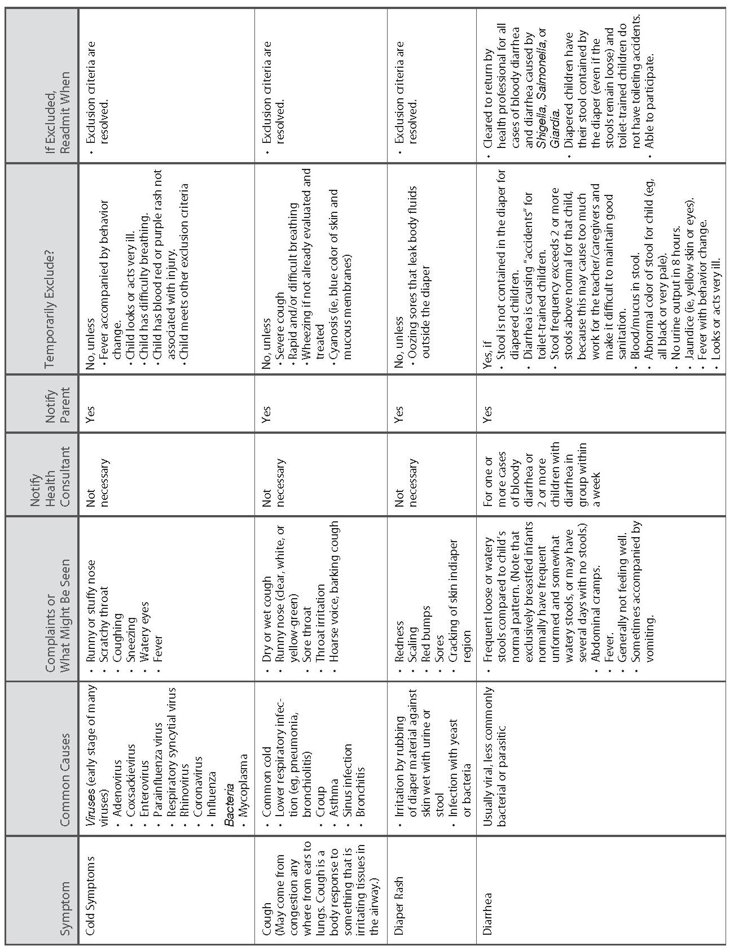

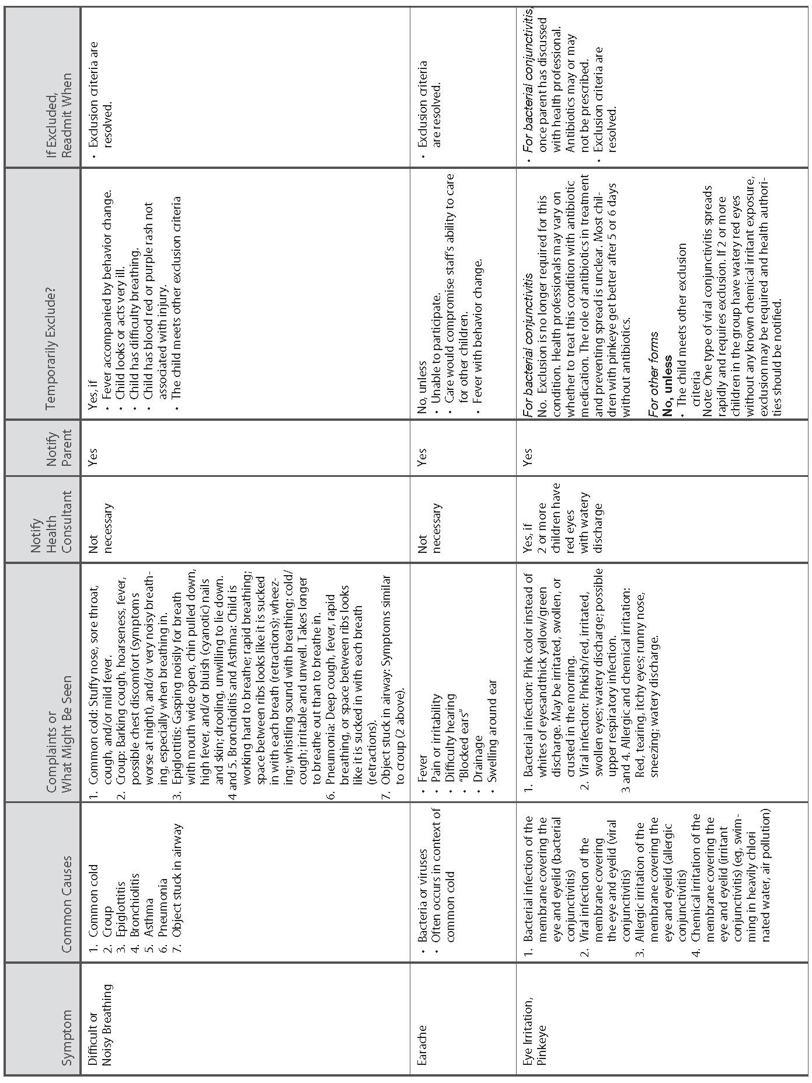

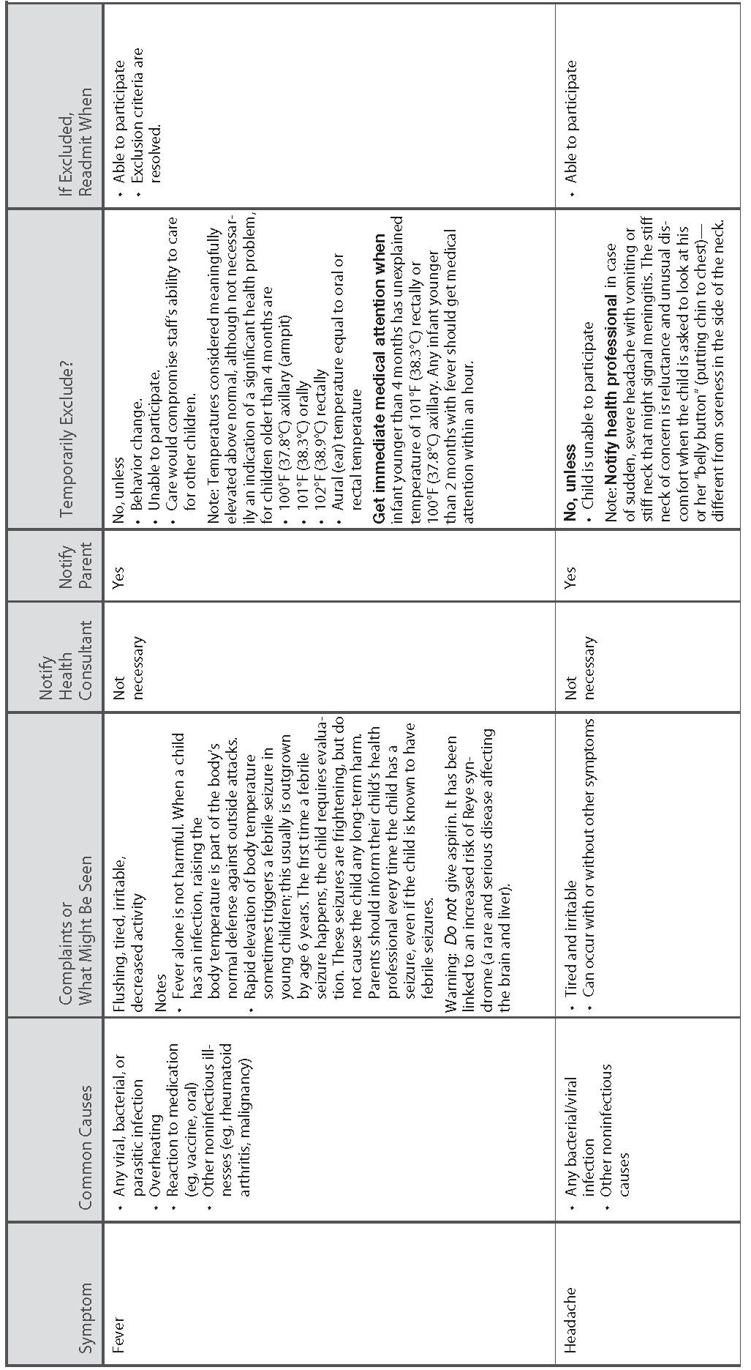

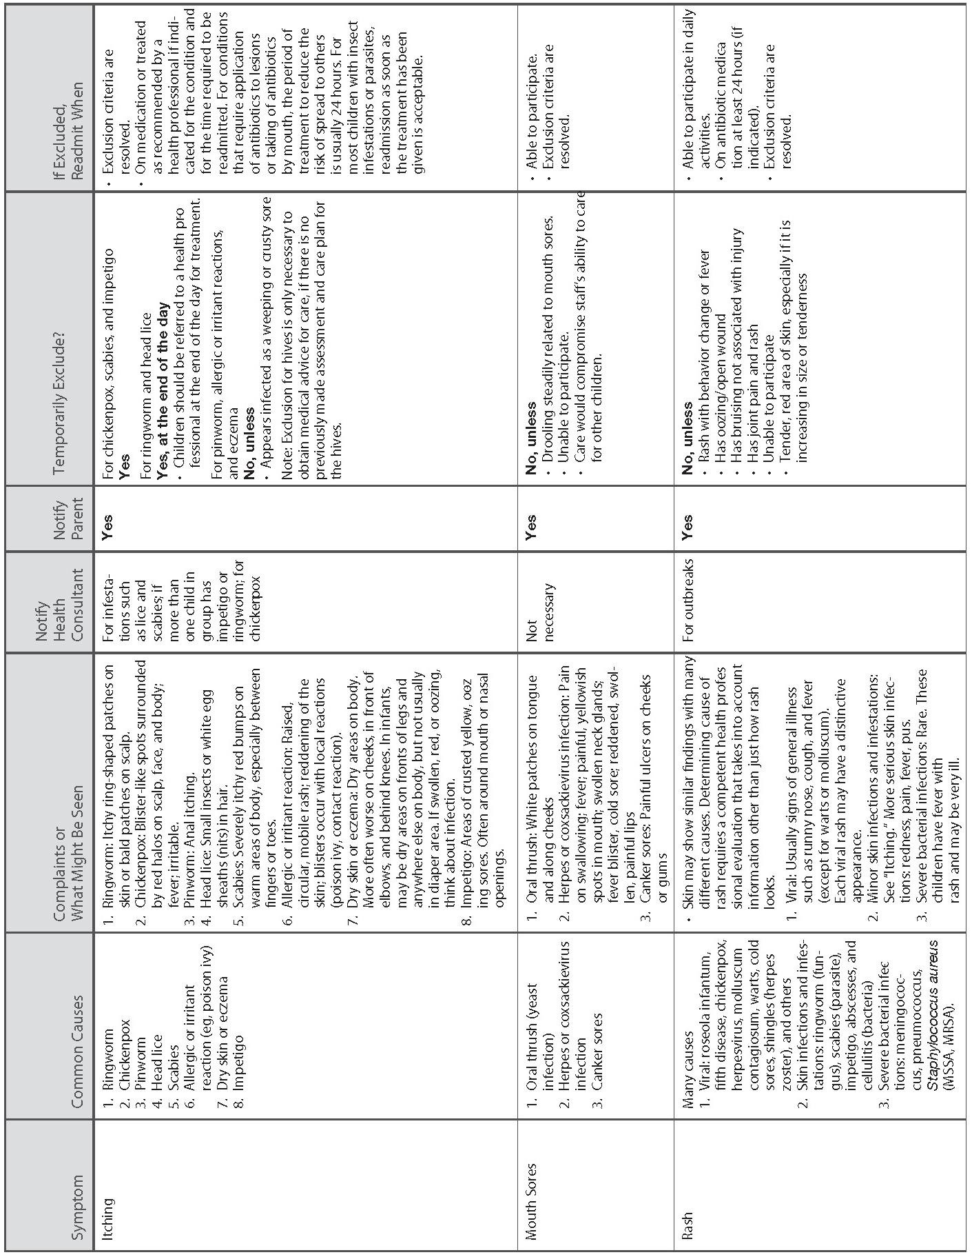

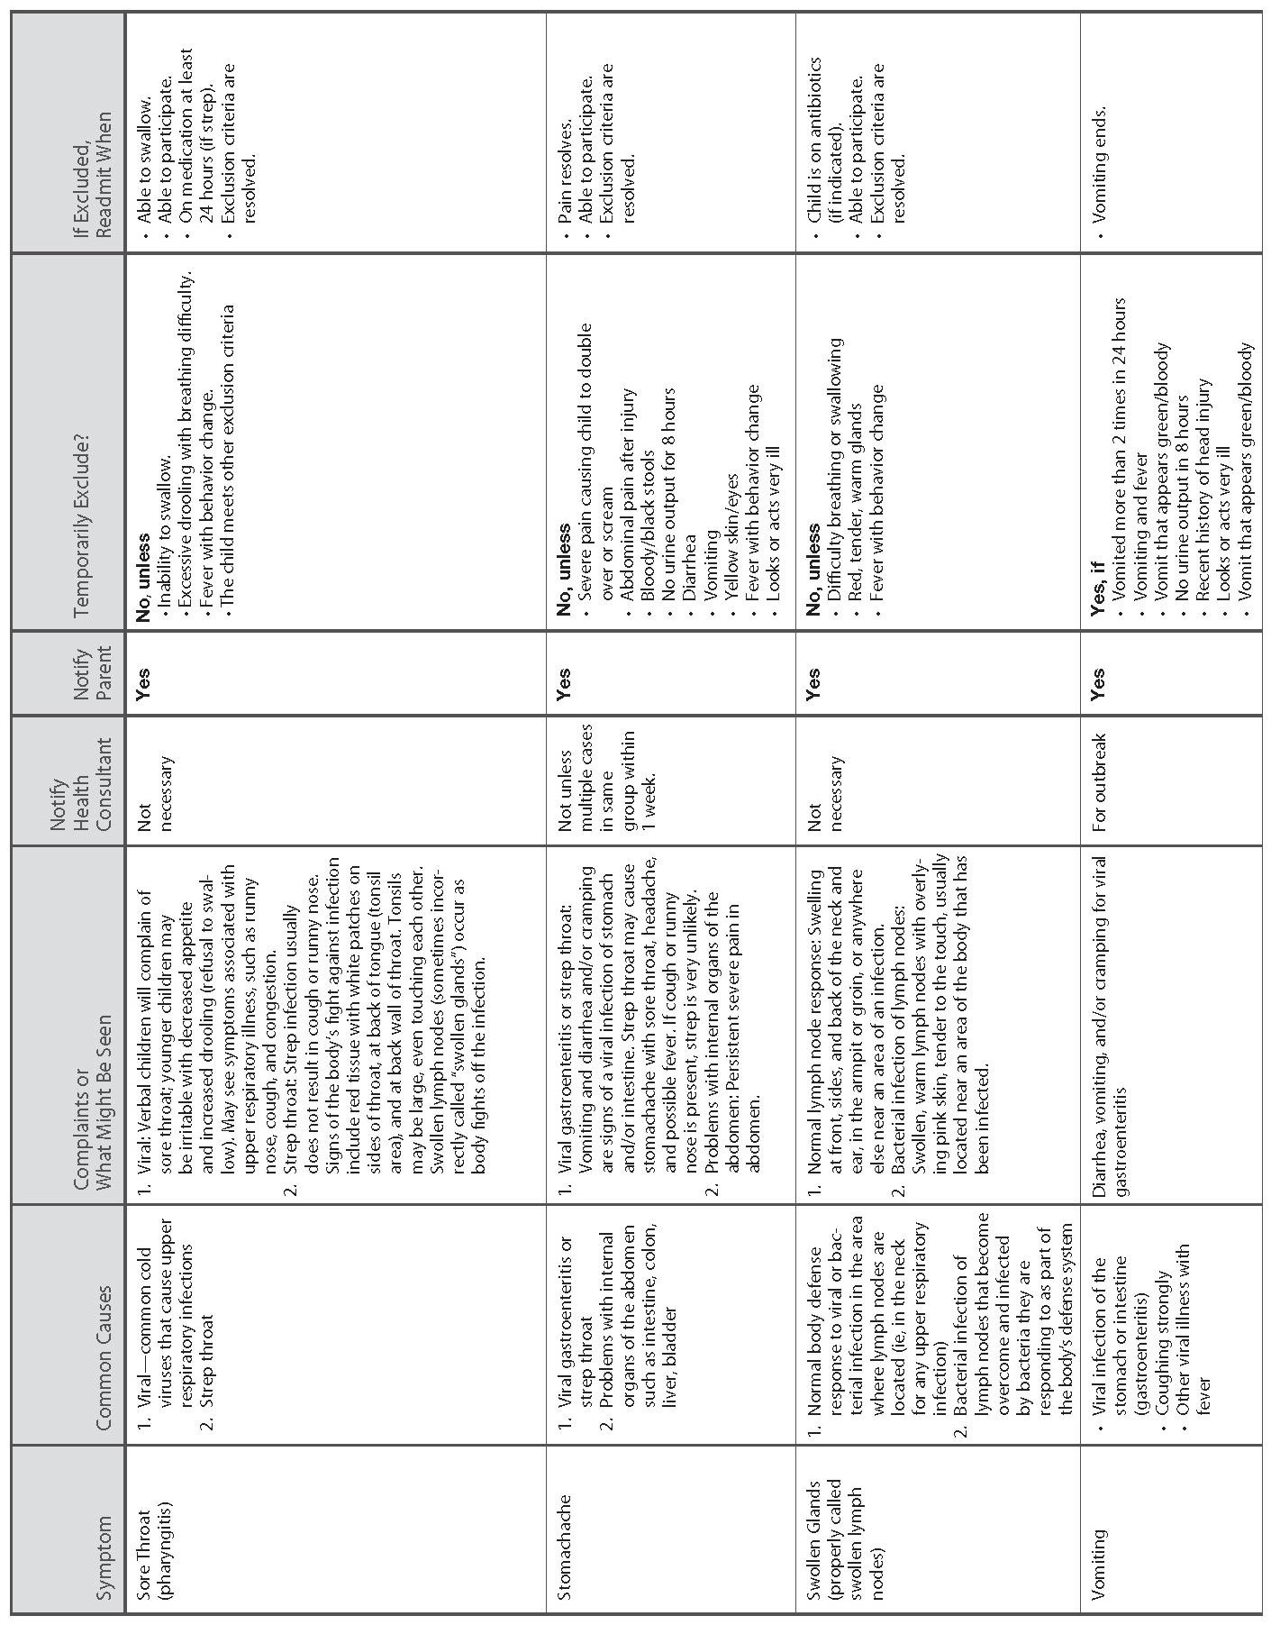

i American Academy of Pediatrics, American Public Health Association, & the National Resource Center for Health and Safety in Child Care and Early Education. (2011). “Appendix A - Signs and Symptoms Chart” in Caring for our children: National health and safety performance standards: Guidelines for out-of-home child care programs, Third edition. Retrieved March 2, 2012 from http://nrckids.org/CFOC3/index.html.

CYP Accreditations

The National Association for the Education of Young Children (NAEYC) promotes high-quality early learning for all children, birth through age 8, by connecting practice, policy, and research and they advance a diverse, dynamic early childhood profession and support all who care for, educate, and work on behalf of young children.

The Council on Accreditation (COA) has standards for Child and Youth Development programs that are designed to promote a program’s capacity to provide quality experiences that help children and youth thrive.

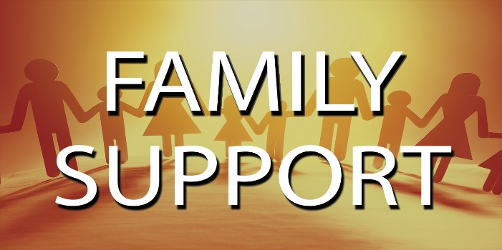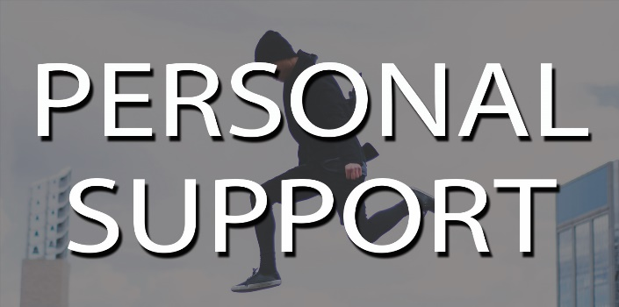
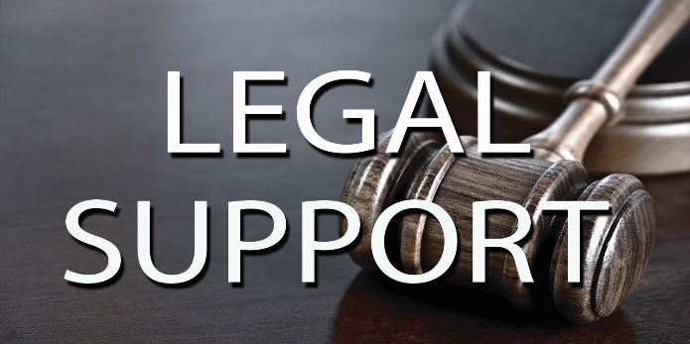

Emergency Numbers
Airman Against Drunk Driving: 226-2232  AFRC: 226-4735  Air Force Aid Society: 226-9899  ADAPT: 226-3230  American Red Cross: 226-3016  BHOP: 226-6372  Casualty Assistance: 226-4735 or 226-9899  Chapel: 226-4630  Command Post: 226-9899  Domestic Abuse VA: 226-2123  Equal Opportunity: 226-3669  Family Advocacy: 226-2123  Force Support Squadron: 226-9272  Legal Assistance: 226-4022 | Medical Clinic: 226-6111 or 0176-77-6111  Mental Health: 226-3230 or 226-9899  MFLC: 226-2147 or 090-2885-8902  Military One Source: 94-800-342-9647  OSI: 226-3116  Security Forces: 226-3600  SAPR: 226-7277 or 226-7272  Suicide Prevention: 94-800-273-8225  Tricare: 226-6111, Option 5  Urgent Care: 226-6647

